 **Practice Test (Mock Test)**

Module Code: 7SENG010W

Module Title: Data Structures & Algorithms

Date:

Start Time:

Time Allowed: 1 Hour, 30 minutes

RAF Time Allowed: 2 Hours

INSTRUCTIONS FOR CANDIDATES

Answer ALL questions.

@University of Westminster

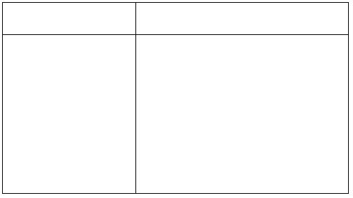School of Computer Science & Engineering

Module Code: 7SENG010W

Module Title: Data Structures & Algorithms

Question 1

(a) You are given the following run-time data for an algorithm. Based on this

data give the algorithm’s complexity class and provide a justiﬁcation ofyour answer.

Input Size Milliseconds (ms)

1000 473 2000 1040 4000 1934 8000 400316000 7765

[5 marks]

(b) Calculate the Big-O order of complexity for the following Fun1 method,

give a brief justiﬁcation of your answer:

public int Fun1( int n ){

int answer = 0 ;int i = 0 ; while ( i < n ){

for ( int j = 0; j < i; j++ ){

int k = 0 ;

while ( k < j; )

{

answer = answer + ( (i * j) * k ) ;

}

k++ ;

}

i++ ;

}

return answer ;

} [5 marks]

[TOTAL 10]

ꢀc University of Westminster Page 2

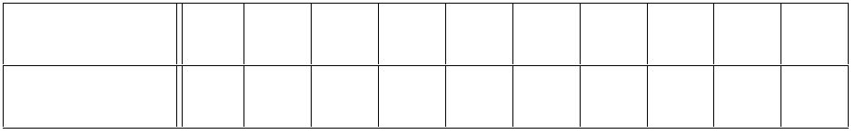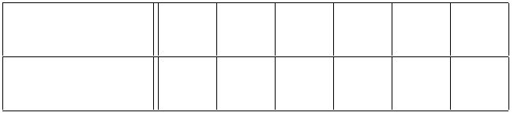School of Computer Science & Engineering

Module Code: 7SENG010W

Module Title: Data Structures & Algorithms

Question 2

The BinarySearch method:

public int BinarySearch( int[] searchArray, int value )

performs a binary search on its ﬁrst integer array parameter to search for itssecond parameter, returning the array index of value if found or -1 if not found.

Use the 10 element integer array Numbers1 as the ﬁrst parameter:

Index 0 1 2 3 4 5 6 7 8 9

Numbers1 9 14 19 23 28 34 40 47 55 75

So for each of the following calls of BinarySearch, give the index of theNumbers1 array elements that are checked by the method in the order checkedand an explanation of why they were checked and the ﬁnal result.

(a) BinarySearch( Numbers1, 23 ) ; [5 marks]

(b) BinarySearch( Numbers1, 63 ) ; [5 marks]

[TOTAL 10]

Question 3

Given the 6 element integer array Numbers2:

Index 0 1 2 3 4 5

Numbers2 53 42 79 65 33 24

Perform the Select/Bubble Sort algorithm on the below array below. Show the new state of the array after each pass of the algorithm and list the “swaps” carried out during each pass.

[10 marks]

[TOTAL 10]

ꢀc University of Westminster Page 3

School of Computer Science & Engineering

Module Code: 7SENG010W

Module Title: Data Structures & Algorithms

Question 4

You are given the following singly linked list operation:

Delete( SLList sll, int x )

– delete x from the singly linked list sll.

and the singly linked list sllist:

head 42 10 99 23 60

Figure 1: Singly linked list sllist

Brieﬂy describe the main steps and including the states of sllist that the

operation would perform during the execution of Delete( sllist, 99 ). [10 marks]

[TOTAL 10]

ꢀc University of Westminster Page 4

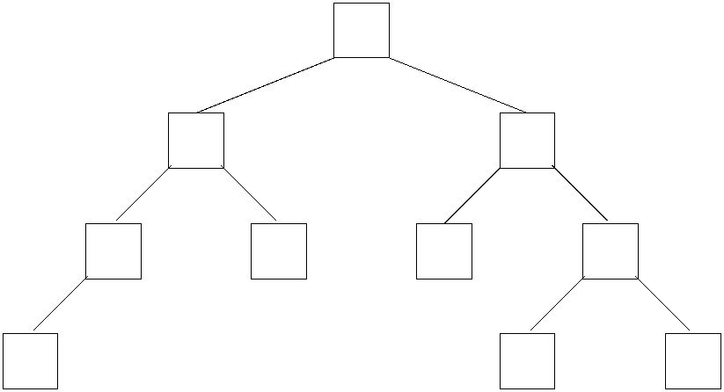School of Computer Science & Engineering

Module Code: 7SENG010W

Module Title: Data Structures & Algorithms

Question 5

Given the following binary tree:

51

12 64

82 16 9 97

31 43 25

Figure 2: A binary tree

(a) In relation to the binary tree in Figure 2 your answer the following questions:

• State the height of the sub-tree with root 12 and justify your answer.

• List the node values that are at level 2 in the tree. [4 marks]

(b) List the tree’s node values in the order “processed” when the tree is tra-

versed using:

• In-Order traversal.

• Post-Order traversal, [6 marks]

[TOTAL 10]

ꢀc University of Westminster Page 5

School of Computer Science & Engineering

Module Code: 7SENG010W

Module Title: Data Structures & Algorithms

Question 6

(a) What is the main property of a Binary Search Tree (BST)? [2 marks]

(b) Create a BST by inserting the following list of integers:

50, 30, 61, 48, 17, 72, 66, 91

one number at a time, in the order given, into an initially empty BST.

Illustrate the result of each insertion by drawing the BST after each inser-

tion, i.e. 8 BST diagrams in total. [6 marks]

(c) Using your ﬁnal BST from part (b) as the current state of the tree, then

assume the number 50 has been deleted from it using the BST deletionoperation, thus resulting in a BST with all the original numbers except 50.

Draw the state of this resultant BST after 50 has been deleted from it. [2 marks]

[TOTAL 10]

ꢀc University of Westminster Page 6

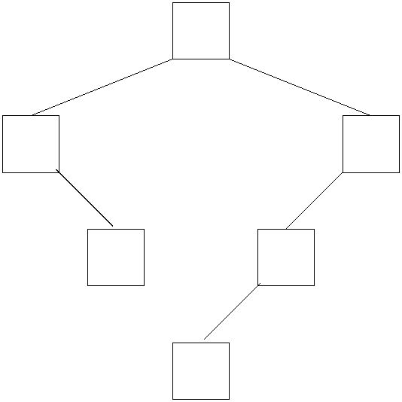School of Computer Science & Engineering

Module Code: 7SENG010W

Module Title: Data Structures & Algorithms

Question 7

The number 28 has just been inserted into the binary search tree in Figure 3.

25

10 35

20 33

28

Figure 3: A binary search tree

(a) Why is the binary tree in Figure 3 not a valid AV L tree? [4 marks]

(b) Re-balance the tree in Figure 3 to produce an AV L tree. Draw the newly

balanced AVL tree and state which rotation(s) were used on which nodes

to re-balance it. [4 marks]

(c) Assume that the number 12 has been inserted in to your AV L tree from

part (b).

Re-balance this tree to produce an AV L tree. Draw the newly balanced AV Ltree and state which rotation(s) were used on which nodes to re-balanceit. [10 marks]

Question 8

[TOTAL 20]

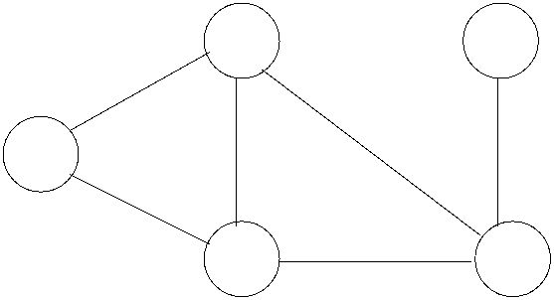School of Computer Science & Engineering

Module Code: 7SENG010W

Module Title: Data Structures & Algorithms

You are given the following undirected weighted graph:

B E 4

9 2

A 5

9

C D 7

Figure 4: An undirected weighted graph

Apply Dijkstra’s Single Source Shortest Path algorithm to the graph given inFigure 4. Use node A as the source. Give the algorithm’s output for the graph in the form of a table, that includes the vertices, edge to a vertex, distance from A to the vertices and the paths. [20 marks]

ꢀc University of Westminster Page 8